## Traffic Flagman’s Hand Gesture Recognition for Autonomous Cars

### Submitted By

Rafiullah Waseem 14PWCSE1200

Momina Razzaq 14PWCSE1165

Shahzad Zaman Khan 14PWCSE1187

## Supervised by

Dr. Nasir Ahmad



2017-18

Department of Computer Systems Engineering

University of Engineering & Technology, Peshawar

**Certificate of Approval**

We approve the project proposal of Rafiullah Waseem, Momina Razzaq and Shahzad Zaman Khan titled “Traffic Flagman’s Hand Gesture Recognition for Autonomous Cars” submitted to Department of Computer Systems Engineering, UET Peshawar in partial fulfillment of requirement for the degree of B.Sc. (CSE).

**Dr. Nasir Ahmad**  ___ __________

Supervisor

**Prof./Dr**  ___ __________

Evaluation Committee Head

**Dr. Abdul Hafeez**  ___ __________

FYP Coordinator, DCSE

**Introduction**

The commonly used input devices for computers did not change much in the recent past. This means that the communication with computers remained limited to mouse, keyboard, track ball, web-cam, light pen and etc. Vision based interfaces are feasible and popular at this moment because the computer is able to communicate with user using webcam. Lately, there has been an increase in interest in recognizing human hand gestures. Hand gesture recognition has several applications such as computer games, sign language, gaming machines, traffic control, as mouse replacement and machinery control (e.g. crane, surgery machines). In this project we will concentrate on recognition of hand gestures of traffic warden for traffic control application. In this modern era computer based self-driving cars are already introduced in the market. In many countries including Pakistan, the traffic is being controlled and directed by traffic wardens. Taking this application into account, this project will develop a system which operates on image processing techniques to extract the image of sign gestures of traffic warden and will be able to recognize it by comparing it with the pre stored image database.

The system can be implemented using different techniques and platforms, such as MATlab, C#, C++, OpenCV. This project will follow the approach based on factors such as reliability, computational overload and sustainability.

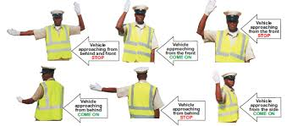

There are few ways to perform hand gesture recognition. Let’s classifies it into three categories. The first category is involved heavily in hardware parts such as glove based analysis, employ sensors (mechanical or optical) attached to a glove that transduce finger flexions into electrical signals to determine the hand posture. Normally, the sensors that used are acoustic or magnetic sensor which embedded into the glove. The second category is analysis of drawing gesture, which are involved using special input devices such as stylus. Most of hand gesture recognition currently works by using mechanical sensing, most often for direct manipulation of a virtual environment. But this type of sensing has a range of problems such as accuracy, reliability and electromagnetic noise.  These two categories involved external hardware parts. The third category is vision based analysis which is based on the way human beings perceive information about their surroundings. Visual sensing has the potential to make gestural interaction more practical and this type of method is most intuitive method to perform hand gesture recognition because it involved no external hardware part, this mean it can recognize our hand gesture freely without anything put on our hand.

**Problem Statement:**

For an autonomous car to understand and recognize the gestures being shown by the warden, there should be a system which should be capable enough to extract and recognize the image of traffic warden controlling the traffic at day time and make appropriate decision.

**Motivation of the Project**

The aim of this project is creating visual biased analysis application to perform Hand Gesture Recognition of traffic warden for an autonomous car. This project will be able to recognize a few hand gestures of traffic wardens such as hand gestures for stopping the car, left move, right move and come on etc. successfully without any error regardless the person hand sizes and other external causes. The goal is to not involve external hardware/part except computer equipped with webcam to minimize the cost.

**Objectives:**

a)    Implementation of pattern recognition system.

c)    The implemented application should be user friendly enough for anyone to use.

d)    System should be able to get static image through the webcam and perform the classification.

b)    The implemented system should able to perform classification correctly.

**Methodology:**

The first steps that need to do in this project are creation of image database. The image database can have different formats. For example, images can be digitalized photographed, 3D dimensional hand and hand drawn. For this project, digitalized photographed will be used because they are the most realistic approach. The images are captured using laptop with webcam. Images used by this project are ‘.jpg’ file. There will be an operation needed to be carried out for all the images. These images will go through a transformation approach called Transformation T. This transformation will convert an image into a feature vector, which will be then compared with other feature vectors of a stored set of gestures. This will use Euclidean distance metric.

Design phase:

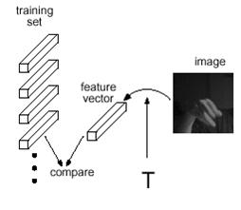

Database set

This method is chosen because it is fast and simple algorithms.

One of the aspects of gesture recognition is **translation invariance**. The position of hand inside the image should not affect the feature vector. This can be done by forming a ***local histogram*** of the ***local orientations***. This approach will treat each orientation element the same but independent of location. Another aspect of gesture recognition is **illumination variance.** In illumination variance:

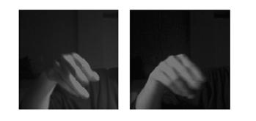

Comparing a pixel-by-pixel difference of the same image but under different lightning condition would misclassify these two same gestures but **orientation histogram**is robust in lighting change condition.

Implementation phase:

This project is limited the hardware part to computer and webcam, we just need to consider the software and programming parts. There are few software can perform hand gesture recognition such as MATLAB, Microsoft Visual C#, Microsoft Visual C++, and Microsoft Visual Basic, OpenCV  with correct way of programming but the most common software are MATLAB and Microsoft Visual C#. The approach followed will depend upon further research related project that the system should be reliable and sustainable.

Testing phase:

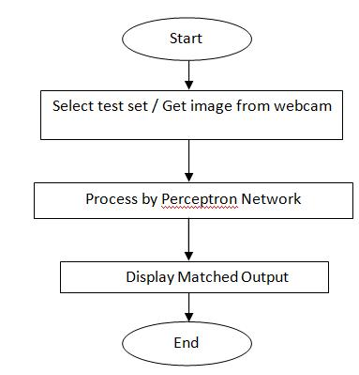

Comparison with stored database

**Evaluation phase:**

The system will display result in form of column format. Each column is a classified image vector. For example when we will be testing for “stop”, it should display the following image.

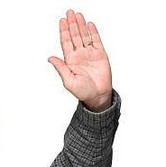

**Block Diagram**



Comparison with stored database

**Applications/Features:**

This project will successfully implement pattern recognition, able to obtain static image as input through webcam on spot and provide user friendly application. Hand gesture recognition has several of applications such as computer games, gaming machines, sign language, as mouse replacement and machinery control (e.g. crane, surgery machines). What important is there is no extra hardware to perform pattern recognition other than webcam and a laptop itself.

**Gantt Chart:**

|  |  |  |  |  |  |  |  |
| --- | --- | --- | --- | --- | --- | --- | --- |
| Work/Schedule Plan | **Month**  **Year** | **Month**  **Year** | **Month**  **Year** | | **Month**  **Year** | **Month**  **Year** | **Month**  **Year** |
| Literature Survey |  |  |  | |  |  |  |
| Experimental work |  |  |  | |  |  |  |
| Sample Testing |  |  |  | |  |  |  |
| Observation and calculation of Results |  |  |  | |  |  |  |
| Thesis writing |  |  |  |  | |  |  |

**References:**

[1] Don Harris, Constantine Stephanidis, Julie A Jacko (2003). Human Computer Interaction: Theory and Practice. Lawrence Erlbaum Associates.